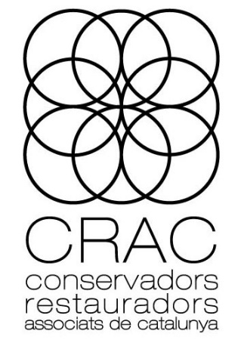
Documentation in Conservation-Restoration
Methods and New Technologies
XVI TECHNICAL MEETING

12th and 13th November 2020
Barcelona Design Museum

Model for the abstract of papers (maximum 500 words) to return to the email address: reuniotecnica@cracpatrimoni.com

Title:

Author (s):
Profession:
Address:
Telephone:
Email:

Introduction:

Subject:

Conclusions:

